**Integrative case study**: **fNIRS retinotopy (rotating wedge)** 2 lectures

Objectives

1. filtering
2. spectral analysis
3. Estimation of strongest spatial response to wedge position (retinotopy)?
4. (note only) Lead to image reconstruction (y=Ax w regularized inverse)

Refs:

* Eggebrecht et al, Neuroimage 2012, <https://www.ncbi.nlm.nih.gov/pmc/articles/PMC3581336/>
* Eggebrecht et al, Nature 2014
* White et al 2010?

**Background**

* 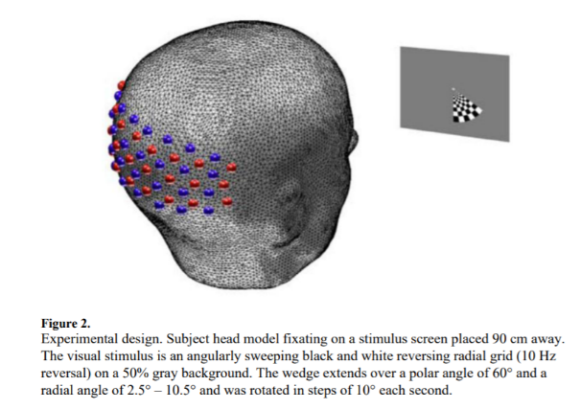**Slides for lecture, ref to Adam papers, other as needed**
  + **CCW Stimulus: basics, main idea, key details (stim frequency, other periodic: flicker, pulse, respiratory)**
  + **Grid layout**
  + **fNIRS basics: s-d distance and sensitivity to depth, analysis of differential signals**
  + **Basic processing (log-ratio)**
    - **SSR? Might be necessary?**
* **Figs for context**

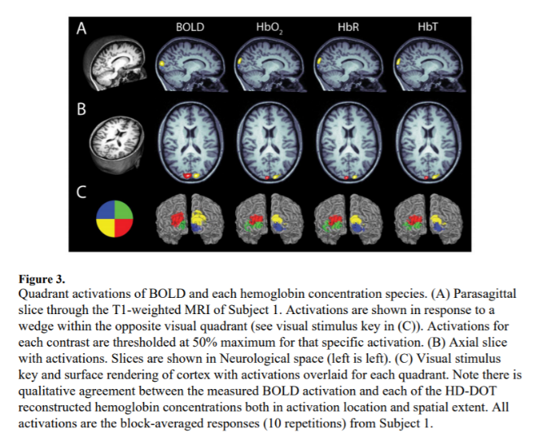**Methods**

* **Data structures to get started**
  + **data**
  + **info, with description of minimal set of needed elements (optode positions, rough relative position to cortex, ordering (key) of measurements)**